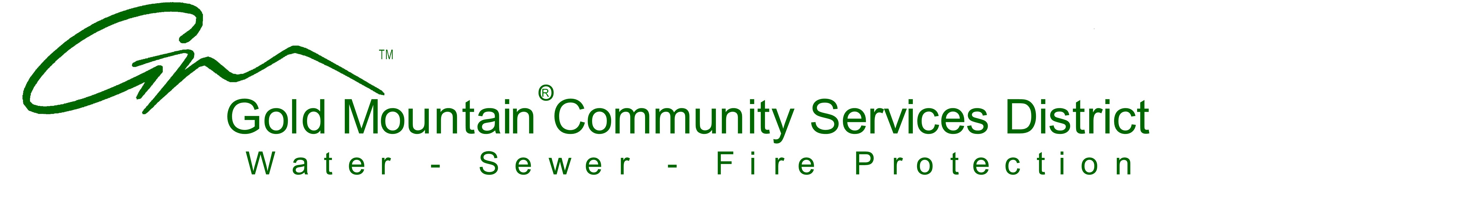

NOTICE OF CANCELLATION

The regular board meeting of the Gold Mountain Community Services District Scheduled for:
Monday, February 15th, 2021 at 10:00am
is hereby cancelled

P.O. Box 5, Clio, CA 96106 ~ 530-832-5945 ~ fax: 530-832-4591
email: goldmtncsd@sbcglobal.net ~ website: goldmountaincsd.org

